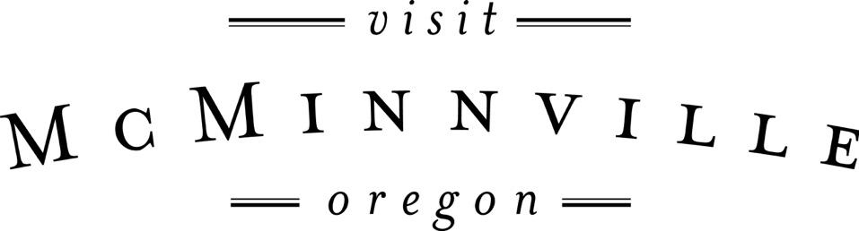

Board of Directors Meeting
Wednesday, September 21st, 2016 – 9:30-11:30am
Visit McMinnville Offices

Agenda

1. Approval of Minutes from Last Board Meeting (1 minute)

2. Financial Overview (15 minutes) Call in from Scott Greenstone

3. PR, Social Media and Website Reporting (20 minutes)

4. Wayfinding Committee + Consultant Budget (20 minutes)

5. Visit McMinnville Board Retreat (15 minutes)

6. Fall/Winter Digital Creative Campaign (15 minutes)

5. Updates Since Last Meeting (30 minutes)
- Sionnie LaFollette Tourism Photography Project Wrap Up
- Falls Event Center Meetings
- OAS 2018 Meeting
- Survey Ambassadors
- FEAST Festival + VM Activations
- Wine Walk + Umbrella Share
- MURAC meeting report
- Jeff + Leadership MAC & Chamber
- Airstrip Attack + Shift Sector
- Zagster + bike share and cycling in general
- ODOT + McDougal junction signage

9. Public Comments (10 minutes)

10. Board Round Table (as time permits)

