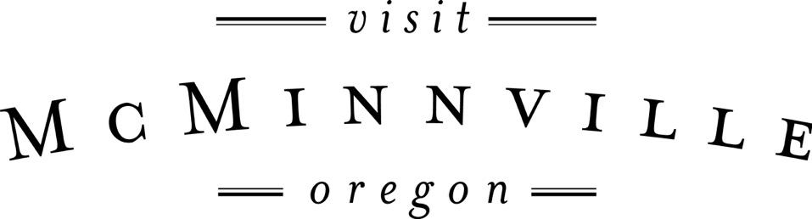

Board of Directors Meeting
Wednesday, October 19th, 2016 – 9:30-11:30am
Visit McMinnville Office

Agenda

1. Approval of Minutes from Last Board Meeting (1 minute)

2. Financial Overview (15 minutes) Call in from Scott Greenstone

3. PR, Social Media and Website Reporting (20 minutes)

4. Wayfinding Committee Report (20 minutes)

5. Visit McMinnville Board Retreat (15 minutes)

6. Blue Chalk Brand Video and Sionnie LaFollette Photography Presentation (15 minutes)

7. Updates Since Last Meeting (30 minutes)
- City Update- City Manager and Mayor positions
- Board Position Update
- Audit Update
- Policy Updates
- Survey Progress
- MURAC
- Cycling Research
- Website Trip Planner Research and Grant $s
- Umbrella Share
- State of the City Breakfast October 25th

8. Public Comments (10 minutes)

9. Board Round Table (as time permits)

