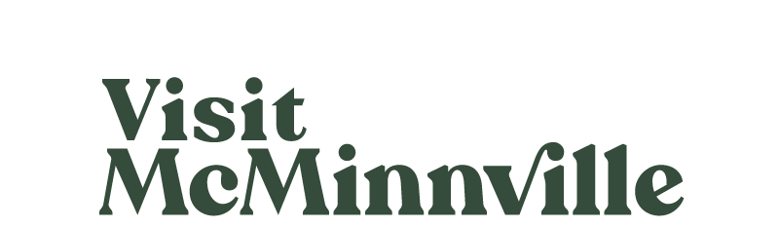

Board of Directors Meeting
Wednesday, June 21, 2023
Zoom

Present: Whyte, Gilchrist, Chisholm, Feero, Macy-Baker, Lorenzen, Stephenson, Smith, Garvin, Cunningham, Towery
Absent:
Guests: Jenny Berg
Staff: Knapp, McGuire, McCollins

- Call to Order
Knapp called the meeting to order at 9:35am.
- Review of May Minutes
Knapp reviewed May meeting minutes. McGuire noted that Feero was not reflected as absent. Smith moved to approve the minutes from the May Board of Directors meeting with the noted change. Whyte seconded. Minutes from the May Board of Directors were approved unanimously, with the noted change.
- Review of April Financials
Knapp reviewed April financial documents. Financials were in line with budget, with a small amount of change due to not hiring in the originally expected timeline. Smith noted that executive committee reviewed the documents and requested clarification on tenant improvements. Knapp made sure those were updated by Michelle Senior.

Smith moved to approved the April financials as presented, Gilchrist seconded. Financial documents were approved unanimously as presented.
- Board Updates
- While this meeting was Cunningham’s last, she was unable to attend. The executive committee will discuss ways to thank her.
- Diana Riggs will be attending the next meeting as a new Board member.
- Staffing Updates
  - Hello McMinnville
VM hired Kris Wessel to manage the Hello McMinnville program. She will be working on a needs assessment and is meeting with members of the community. Knapp noted VM’s executive committee and Kris met with the MDA executive committee to start conversations about first steps. Chisholm gave feedback from the MDA.
Knapp noted conversations held with the MDA on a potential TID (tourism improvement district) for McMinnville. Knapp spoke with Civitas and referred to white papers released by their company that support various methods of implementation.
  - Destination Development Manager
Knapp updated the Board that VM has pushed pause on hiring this position until early 2024. Funds originally allocated for this position will be redeployed to marketing and other efforts.

  - RARE Position
VM will be interviewing 6 potential RARE candidates; the position will begin in early September. There will be 2 other RAREs placed in the Willamette Valley.
- Reports and Updates
  - Development
- With help from Jenny Berg and Matt Deppe, McMinnville was approved for rebates for 12+ EV charging stations in the downtown core and parking garage. The City has applied to be a partner with Tualatin for other EV investments.
- Travel Oregon has given VM $30,000 to pay for the environmental studies needed for the 25+ miles of Panther Creek mountain biking trails. Completion of those studies should be in December 2023; following this, the BLM will be able to move ahead with more planning.
  - Marketing
McGuire gave a marketing presentation on recent efforts, including ongoing paid advertising, vertical video creation, upcoming projects, recent media and influencer visits, and local summer event support.
  - City & MEVLC
- The VM building will be painted in our brand green in the next week, and sewer fixes needed to be made; Knapp is working with the building owner to cover costs.
- Workforce efforts are continuing.
- The City is working to develop a relationship with OSU; OSU may focus resources on food and fermentation science and the Yamhill County Extension office.
- The City and MEVLC is making forward progress on the RB project.
- VM gave a presentation to the City Council on our business plan and budget. VM’s budget and plan was unanimously approved.
- Garvin gave an update on funding asks at the state level; things are in a stalemate currently and he expects it could get pushed out another year.
- Knapp noted he is attending the City’s houselessness committee to work on solutions for safety.

The meeting was adjourned at 10:35am.

The next Board of Directors meeting will be held on July 19, 2023.
Minutes were recorded and respectfully submitted by Kitri McGuire.

